Question 14 (7 marks)

(a) Show that $\begin{matrix}4 \\ \overline{x-3}\end{matrix}+\begin{matrix}6 \\ \overline{x^{2}+9}\end{matrix}=\begin{matrix}4x^{2}+6x+18 \\ \overline{x^{3}-3x^{2}+9x-27}\end{matrix}$. (1 mark)

(b) Hence show that $\int_{-3}^{0}{\left(\begin{matrix}4x^{2}+6x+18 \\ \overline{x^{3}-3x^{2}+9x-27}\end{matrix}\right)}dx=\begin{matrix}π \\ \overline{2}\end{matrix}-4\ln{2}$, using the substitution $x=3\tan{θ}$ 
 where appropriate. (6 marks)

Question 14 (7 marks)

(a) Show that $\begin{matrix}4 \\ \overline{x-3}\end{matrix}+\begin{matrix}6 \\ \overline{x^{2}+9}\end{matrix}=\begin{matrix}4x^{2}+6x+18 \\ \overline{x^{3}-3x^{2}+9x-27}\end{matrix}$. (1 mark)

|  |
| --- |
| Solution |
| $$\text{LHS}=\frac{4}{x-3}+\frac{6}{x^{2}+9} \\ =\frac{4x^{2}+36+6x-18}{\left(x-3\right)\left(x^{2}+9\right)} \\ =\frac{{4x}^{2}+6x+18}{x^{3}-3x^{2}+9x-27}=\text{RHS}$$ |
| Specific behaviours |
| ✓ combines into single fraction with expanded numerator |

(b) Hence show that $\int_{-3}^{0}{\left(\begin{matrix}4x^{2}+6x+18 \\ \overline{x^{3}-3x^{2}+9x-27}\end{matrix}\right)}dx=\begin{matrix}π \\ \overline{2}\end{matrix}-4\ln{2}$, using the substitution $x=3\tan{θ}$ 
 where appropriate. (6 marks)

|  |
| --- |
| Solution |
| When $x=3\tan{θ}:$ $$dx=3\sec^{2}{θ}dθ; x^{2}+9=9\tan^{2}{θ}+9=9\sec^{2}{θ}; x=0, θ=0; x=-3, θ=-\frac{π}{4}$$ $$\int_{-3}^{0}{\frac{6}{x^{2}+9}}dx=\int_{-\frac{π}{4}}^{0}{\frac{6×3\sec^{2}{θ}}{9\sec^{2}{θ}}}dθ \\ =\int_{-\frac{π}{4}}^{0}{2}dθ \\ ={\left[2θ\right]}_{-\frac{π}{4}}^{0}=\frac{π}{2}$$ Hence $I=\begin{matrix}π \\ \overline{2}\end{matrix}-4\ln{2}$. |
| Specific behaviours |
| ✓ antidifferentiates first integral, using absolute value brackets  ü substitutes and simplifies to obtain $-4\ln{2}$ ü uses substitution to relate $dx$ and $dθ$ ü adjusts bounds of integration  ü writes and simplifies second integral in terms of $θ$ ü antidifferentiates and substitutes to obtain $\begin{matrix}π \\ \overline{2}\end{matrix}$ and hence $I$ |

Question 15 (7 marks)

<EFOFEX>
id:fxd{c0a07404-534d-4fd4-afde-f5518418e4e2}

FXData:
</EFOFEX>(a) Use the substitution $u^{2}=2y+5$ to show that $\int{\begin{matrix}y \\ \overline{\sqrt{2y+5}}\end{matrix}}dy=\begin{matrix}\left(y-5\right)\sqrt{2y+5} \\ \overline{ \underset{ }{3} }\end{matrix}+c$,  
where $c$ is a constant of integration. (4 marks)

(b) The equation of the curve shown is $y=x\sqrt{2y+5}$ 
  
.

Determine the area enclosed by the  
curve and the line $3x-y+4=0$. (3 marks)

Question 15 (7 marks)

<EFOFEX>
id:fxd{c0a07404-534d-4fd4-afde-f5518418e4e2}

FXData:
</EFOFEX>(a) Use the substitution $u^{2}=2y+5$ to show that $\int{\begin{matrix}y \\ \overline{\sqrt{2y+5}}\end{matrix}}dy=\begin{matrix}\left(y-5\right)\sqrt{2y+5} \\ \overline{ \underset{ }{3} }\end{matrix}+c$,  
where $c$ is a constant of integration. (4 marks)

|  |
| --- |
| Solution |
| $$u^{2}=2y+5⇒dy=u du, y=\frac{u^{2}-5}{2}$$ $$\int{\frac{y}{\sqrt{2y+5}}}dy=\int{\frac{u^{2}-5}{2u}×u}du \\ =\frac{1}{2}\int{u^{2}-5}du \\ =\frac{1}{2}\left(\frac{1}{3}u^{3}-5u\right)+c \\ =\frac{u}{6}\left(u^{2}-15\right)+c \\ =\frac{\sqrt{2y+5}(2y+5-15)}{6}+c \\ =\frac{\left(y-5\right)\sqrt{2y+5}}{3}+c$$ |
| Specific behaviours |
| ✓ obtains $y$ and $dy$ in terms of $u$ and $du$ ü obtains simplified integral in terms of $u$ ü obtains correct antiderivative  ü shows step(s) that clearly lead to required result |

(b) The equation of the curve shown is $y=x\sqrt{2y+5}$ 
  
.

Determine the area enclosed by the  
curve and the line $3x-y+4=0$. (3 marks)

|  |
| --- |
| Solution |
| $$x=\frac{y}{\sqrt{2y+5}}, x=\frac{y-4}{3}$$ Lines intersect when $y=-2, y=10$. $$A=\int_{-2}^{10}{\left(\frac{y}{\sqrt{2y+5}}\right)-\left(\frac{y-4}{3}\right)}dy \\ =\frac{32}{3}=10.\overline{6}$$ |
| Specific behaviours |
| ✓ obtains bounds of integral  ü writes correct integral for area  ü correct area |

Question 14 (8 marks)

<EFOFEX>
id:fxd{efbce802-c19b-4311-88d2-98866ceb170e}

FXData:
</EFOFEX>Let , where is a constant, and region   
be the area between the -axis and the curve $y=f(x)$.  
  
All dimensions are in centimetres.

(a) When $a=18$, determine the volume of revolution when $R$ is rotated about the $y$-axis.

(5 marks)

(b) When $R$ is rotated about the $x$-axis, the volume of revolution is cm3.  
Determine the value of $a$. (3 marks)

Question 14 (8 marks)

<EFOFEX>
id:fxd{efbce802-c19b-4311-88d2-98866ceb170e}

FXData:
</EFOFEX>Let , where is a constant, and region   
be the area between the -axis and the curve $y=f(x)$.  
  
All dimensions are in centimetres.

(a) When $a=18$, determine the volume of revolution when $R$ is rotated about the $y$-axis.

(5 marks)

|  |
| --- |
| Solution |
| Expressions for inner and outer curves: $$y=x\left(18-x\right)⇒x=9±\sqrt{81-y}$$ When $x=18÷2, y_{max}=81$. $$V_{O}=π\int_{0}^{81}{{\left(9+\sqrt{81-y}\right)}^{2}}dy \left(=\frac{37179π}{2}≈58401\right)$$ $$V_{I}=π\int_{0}^{81}{{\left(9-\sqrt{81-y}\right)}^{2}}dy \left(=\frac{2187π}{2}≈3435\right)$$ $$V=V_{O}-V_{I} \\ =π\int_{0}^{81}{36\sqrt{81-y}}dy \\ =17 496π≈54 965 {\text{cm}}^{3}$$ |
| Specific behaviours |
| ✓ expressions for inner and outer curves  ü obtains maximum value of $y$ ü indicates correct definite integral for inner or outer volume  ü indicates appropriate method to obtain required volume  ü obtains correct volume |

(b) When $R$ is rotated about the $x$-axis, the volume of revolution is cm3.  
Determine the value of $a$. (3 marks)

|  |
| --- |
| Solution |
| $$V=π\int_{0}^{a}{{\left(x\left(a-x\right)\right)}^{2}} dx \\ =\frac{a^{5}π}{30}$$ $$\frac{a^{5}π}{30}=\frac{81π}{10} \\ a=3$$ |
| Specific behaviours |
| ü correct definite integral for volume  ü obtains expression for volume in terms of  ✓ forms equation and solves for $a$ |

Question 17 (7 marks)

A water tank, initially empty, is in the form of an inverted right cone of radius $4$ m and depth $5$ m. Water is flowing into the tank at a steady rate of m3 per minute but leaking out at a rate of m3 per minute, where is the depth of water in the tank.

(a) Determine the rate at which the depth of water is increasing in the tank when the depth of water reaches $3$ m. (5 marks)

(b) Explain whether the tank will ever overflow. (2 marks)

Question 17 (7 marks)

A water tank, initially empty, is in the form of an inverted right cone of radius $4$ m and depth $5$ m. Water is flowing into the tank at a steady rate of m3 per minute but leaking out at a rate of m3 per minute, where is the depth of water in the tank.

(a) Determine the rate at which the depth of water is increasing in the tank when the depth of water reaches $3$ m. (5 marks)

|  |
| --- |
| Solution |
| Required rate is $\frac{dh}{dt}$ when $h=3$.  Rate of change of volume of water in tank: $$\frac{dV}{dt}=0.05-0.002h^{2}$$ Volume as function of depth using $\frac{r}{h}=\frac{4}{5}$: $$V=\frac{1}{3}πr^{2}h \\ V=\frac{1}{3}πh{\left(\frac{4h}{5}\right)}^{2} \\ =\frac{16πh^{3}}{75}$$ Then $$\frac{dV}{dh}=\frac{16πh^{2}}{25} \text{OR }\frac{dV}{dt}=\frac{16πh^{2}}{25}\frac{dh}{dt}$$ Hence $$\frac{dh}{dt}=\frac{dh}{dV}×\frac{dV}{dt} \\ =\frac{25(0.05-0.002h^{2})}{16πh^{2}}$$ When $h=3$ $$\frac{dh}{dt}=\frac{1}{180π}≈0.00177 \text{m per min}$$ |
| Specific behaviours |
| ✓ indicates rate of change of volume wrt time  ü uses height to radius ratio to obtain $V(h)$ ü expression for $\frac{dV}{dh}$ or relates $\frac{dV}{dt}$ and $\frac{dh}{dt}$ ü expression for $\frac{dh}{dt}$ in terms of $h$ ü calculates rate, with units |

(b) Explain whether the tank will ever overflow. (2 marks)

|  |
| --- |
| Solution |
| No. When $h=5$ then $\frac{dV}{dt}=0.05-0.002{\left(5\right)}^{2}=0$ and so the tank will be in equilibrium with flow in equal to flow out. |
| Specific behaviours |
| ✓ states no, with justification  ü explanation |

Question 19 (7 marks)

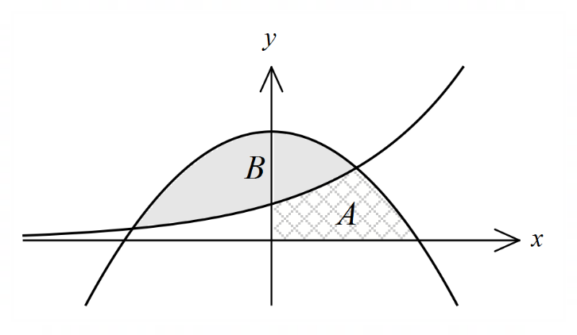Let $f\left(x\right)=4-x^{2}$ and $g\left(x\right)=3^{x}$.

The diagram, not to scale, shows  
the graphs of $y=f(x)$ and $y=g(x)$.  
  
Region $A$, in the first quadrant, is  
bounded by the $x$-axis, the $y$-axis  
and the two curves.

Region $B$, shaded, is bounded by  
the two curves.

(a) Determine the area of region $A$. (3 marks)

(b) Determine the volume of the solid generated when region $B$ is rotated about the horizontal line $y=-2$. (4 marks)

Question 19 (7 marks)

Let $f\left(x\right)=4-x^{2}$ and $g\left(x\right)=3^{x}$.

The diagram, not to scale, shows  
the graphs of $y=f(x)$ and $y=g(x)$.  
  
Region $A$, in the first quadrant, is  
bounded by the $x$-axis, the $y$-axis  
and the two curves.

Region $B$, shaded, is bounded by  
the two curves.

(a) Determine the area of region $A$. (3 marks)

|  |
| --- |
| Solution |
| $$4-x^{2}=3^{x}⇒x=1, x=-1.97112$$ $$A=\int_{0}^{1}{g\left(x\right)}dx+\int_{1}^{2}{f\left(x\right)}dx \\ =\frac{2}{\ln{3}}+\frac{5}{3}≈1.8205+1.6667≈3.487$$ |
| Specific behaviours |
| ✓ integrands  ü correct limits  ü evaluates |

(b) Determine the volume of the solid generated when region $B$ is rotated about the horizontal line $y=-2$. (4 marks)

|  |
| --- |
| Solution |
| Volume generated by rotating region about the line $y=-2$ will be identical to volume generated by translating both functions two units upwards and rotating about the x-axis. $$V=π\int_{-1.97112}^{1}{\left[{\left(f\left(x\right)+2\right)}^{2}-{\left(g\left(x\right)+2\right)}^{2}\right]}dx \\ ≈163.356$$ NB separate integrals: $V≈246.545-83.189$ |
| Specific behaviours |
| ü adds constant to functions  ✓ integrand(s)  ü correct limits  ü evaluates |

Question 10 (5 marks)

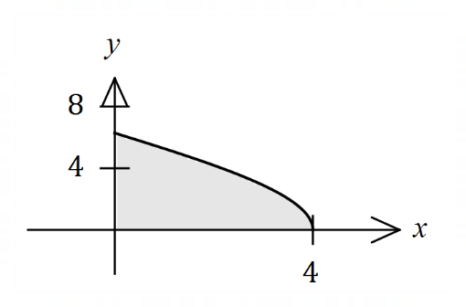The graph of $\begin{matrix}x \\ \overline{4}\end{matrix}=\cos\left(\begin{matrix}y \\ \overline{4}\end{matrix}\right)$ is shown for $0≤y≤2π$.

Show that when the shaded region bounded  
by the curve and the $y$-axis is rotated about  
the $y$-axis, the volume of revolution of the  
solid formed is $16π^{2}$.

Question 10 (5 marks)

The graph of $\begin{matrix}x \\ \overline{4}\end{matrix}=\cos\left(\begin{matrix}y \\ \overline{4}\end{matrix}\right)$ is shown for $0≤y≤2π$.

Show that when the shaded region bounded  
by the curve and the $y$-axis is rotated about  
the $y$-axis, the volume of revolution of the  
solid formed is $16π^{2}$.

|  |
| --- |
| **Solution** |
| $$V=\int_{ }^{ }{πx^{2}}dy, x^{2}=16\cos^{2}\left(\frac{y}{4}\right)$$ $$∴V=\int_{0}^{2π}{16π\cos^{2}\left(\frac{y}{4}\right)}dy, 2\cos^{2}\left(\frac{y}{4}\right)=1+\cos\left(\frac{y}{2}\right)$$ $$∴V=8π\int_{0}^{2π}{1+\cos\left(\frac{y}{2}\right)}dy \\ =8π{\left[y+\sin\left(\frac{y}{2}\right)\right]}_{0}^{2π} \\ =8π\left[2π+\sin{π}\right]-8π\left[0+\sin{0}\right] \\ =8π\left[2π+0\right]-8π[0+0] \\ =16π^{2}$$ |
| **Specific behaviours** |
| ✓ integral for volume in terms of $y$ ✓ uses double angle formula  ✓ correctly antidifferentiates  ✓ clearly shows all substitutions  ✓ simplifies |

Question 13 (7 marks)

(a) Sketch the graph of $y=\begin{matrix}e^{x} \\ \overline{3+x}\end{matrix}$ on the axes below. (2 marks)

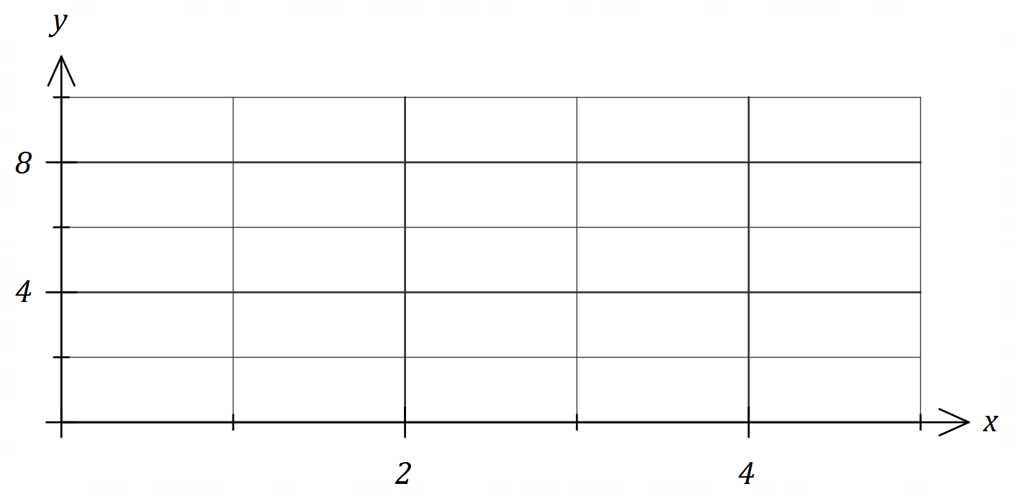

The Trapezoidal Rule can be used to determine the numerical approximation of a definite integral when an antiderivative cannot be found. When a continuous interval is divided into smaller intervals of equal width , the bounds of these smaller intervals can be denoted by . The Trapezoidal Rule is then expressed as follows:

$$\int_{a_{0}}^{a_{n}}{f(x)}dx=\frac{w}{2}\left[f\left(a_{0}\right)+2f\left(a_{1}\right)+2f\left(a_{2}\right)+ ∙∙∙+2f\left(a_{n-1}\right)+f(a_{n})\right]$$

(b) Use the above rule to determine an estimate to $4$ decimal places for $\int_{0}^{4}{\underset{ }{\overset{ }{\begin{matrix}e^{x} \\ \overline{3+x}\end{matrix}}}}dx$ using

(i) $2$ intervals. (2 marks)

(ii) $20$ intervals. (3 marks)

Question 13 (7 marks)

(a) Sketch the graph of $y=\begin{matrix}e^{x} \\ \overline{3+x}\end{matrix}$ on the axes below. (2 marks)

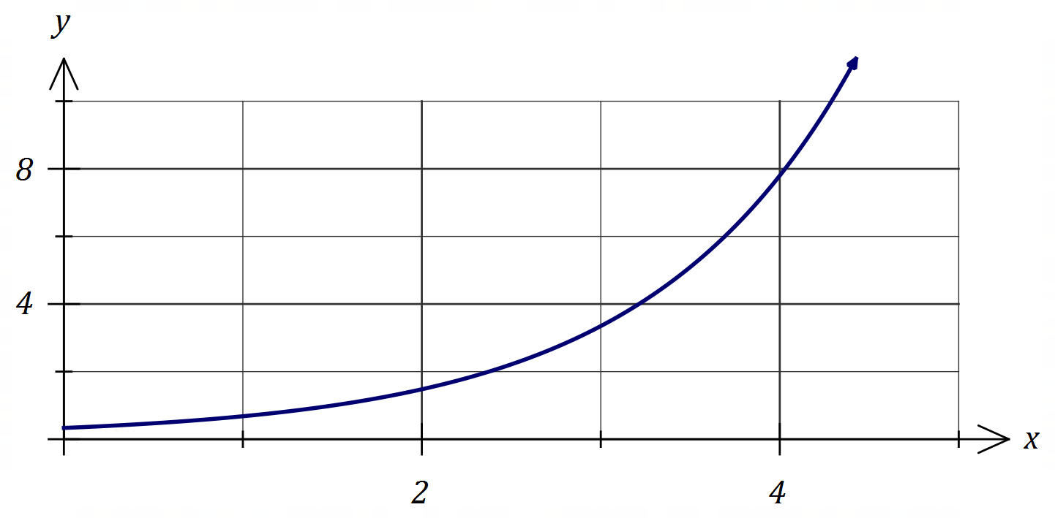

|  |
| --- |
| **Solution** |
| See graph |
| **Specific behaviours** |
| ✓ close to $\left(0,0.3\right) \& (4,8)$ ✓ smooth curve |

The Trapezoidal Rule can be used to determine the numerical approximation of a definite integral when an antiderivative cannot be found. When a continuous interval is divided into smaller intervals of equal width , the bounds of these smaller intervals can be denoted by . The Trapezoidal Rule is then expressed as follows:

$$\int_{a_{0}}^{a_{n}}{f(x)}dx=\frac{w}{2}\left[f\left(a_{0}\right)+2f\left(a_{1}\right)+2f\left(a_{2}\right)+ ∙∙∙+2f\left(a_{n-1}\right)+f(a_{n})\right]$$

(b) Use the above rule to determine an estimate to $4$ decimal places for $\int_{0}^{4}{\underset{ }{\overset{ }{\begin{matrix}e^{x} \\ \overline{3+x}\end{matrix}}}}dx$ using

(i) $2$ intervals. (2 marks)

|  |
| --- |
| **Solution** |
| $$\frac{2}{2}\left(f\left(0\right)+2f\left(2\right)+f\left(4\right)\right)=11.0887$$ |
| **Specific behaviours** |
| ✓ indicates use of rule with correct intervals  ✓ correct estimate, to $4$ dp |

(ii) $20$ intervals. (3 marks)

|  |
| --- |
| **CAS** |
|  |

|  |
| --- |
| **Solution** |
| $$E=\frac{0.2}{2}\left(f\left(0\right)+2f\left(0.2\right)+ ∙∙∙+2f\left(3.8\right)+f\left(4\right)\right) \\ ≈9.0614$$ |
| **Specific behaviours** |
| ✓ indicates use of correct intervals  ✓ indicates use of rule  ✓ correct estimate, to $4$ dp |

Question 14 (8 marks)

A manufacturer drills a hole of radius $r$ through the centre of a solid sphere of radius $R$.

To determine the volume of the remaining solid, consider the circle with equation and the line with equation , as shown in the diagram below.

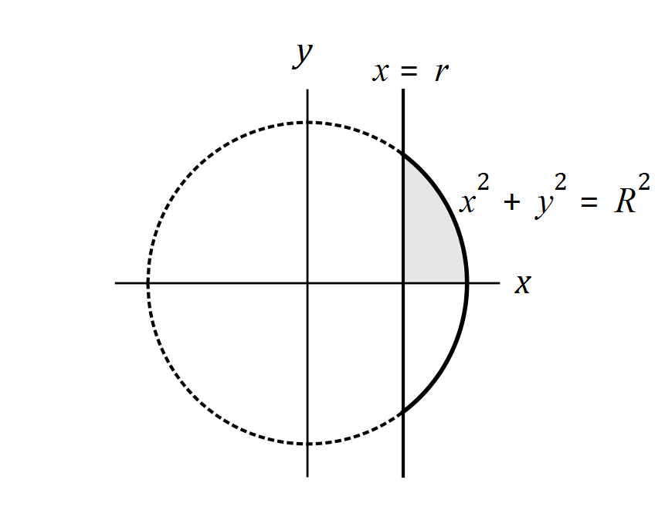

(a) Determine the coordinates of the point of intersection of the line and the circle in the first quadrant in terms of $r$ and $R$. (2 marks)

(b) Construct a single integral to determine the volume of revolution obtained when the shaded region in the diagram is rotated about the $y$-axis. (2 marks)

(c) Evaluate your integral from (b) and hence determine a formula for $V$, the volume of the remaining solid. (3 marks)

(d) Hence, or otherwise, determine the exact volume of the remaining solid when a hole of radius $5$ cm is drilled through the centre of a solid sphere of radius $13$ cm. (1 mark)

Question 14 (8 marks)

A manufacturer drills a hole of radius $r$ through the centre of a solid sphere of radius $R$.

To determine the volume of the remaining solid, consider the circle with equation and the line with equation , as shown in the diagram below.



(a) Determine the coordinates of the point of intersection of the line and the circle in the first quadrant in terms of $r$ and $R$. (2 marks)

|  |
| --- |
| **Solution** |
| $$x=r⇒y=\sqrt{R^{2}-r^{2}}$$ Coordinates: $\left(r, \sqrt{R^{2}-r^{2}}\right)$. |
| **Specific behaviours** |
| ✓ expresses $y$ in terms of $R$ and $r$ ✓ coordinates of point |

(b) Construct a single integral to determine the volume of revolution obtained when the shaded region in the diagram is rotated about the $y$-axis. (2 marks)

|  |
| --- |
| **Solution** |
| $$I=π\int_{0}^{\sqrt{R^{2}-r^{2}}}{{(R}^{2}-y^{2})-(r^{2})}dy$$ $$=π\int_{0}^{\sqrt{R^{2}-r^{2}}}{{(R}^{2}-r^{2})-y^{2}}dy$$ |
| **Specific behaviours** |
| ✓ difference of squares of relations  ✓ correct integral, with limits |

(c) Evaluate your integral from (b) and hence determine a formula for $V$, the volume of the remaining solid. (3 marks)

|  |
| --- |
| **Solution** |
| $$V_{H}=π{\left[\left(R^{2}-r^{2}\right)y-\frac{y^{3}}{3}\right]}_{0}^{\sqrt{R^{2}-r^{2}}} \\ =π\left[\left(R^{2}-r^{2}\right)\sqrt{R^{2}-r^{2}}-\frac{{\sqrt{R^{2}-r^{2}}}^{3}}{3}\right]-\left[\left(R^{2}-r^{2}\right)(0)-0\right] \\ =π\left[{\left(R^{2}-r^{2}\right)}^{\frac{3}{2}}-\frac{{\left(R^{2}-r^{2}\right)}^{\frac{3}{2}}}{3}\right] \\ =\frac{2π\sqrt{{\left(R^{2}-r^{2}\right)}^{3}}}{3}$$ $$V=\frac{4π\sqrt{{\left(R^{2}-r^{2}\right)}^{3}}}{3}$$ |
| **Specific behaviours** |
| ✓ shows correct antiderivative  ✓ substitutes and simplifies $V_{H}$ (hemisphere volume)  ✓ doubles to obtain correct formula |

(d) Hence, or otherwise, determine the exact volume of the remaining solid when a hole of radius $5$ cm is drilled through the centre of a solid sphere of radius $13$ cm. (1 mark)

|  |
| --- |
| **Solution** |
| $$V=\frac{4\sqrt{{\left({13}^{2}-5^{2}\right)}^{3}}}{3} \\ =2304π$$ |
| **Specific behaviours** |
| ✓ correct volume (allow ft from (c)) |

Question 10 (5 marks)

The region $R$ enclosed by the curves $y^{2}=bx$ and $x^{2}=64by$, has an area of $1200$ square units.

Determine the value of the positive constant $b$.

Question 10 (5 marks)

The region $R$ enclosed by the curves $y^{2}=bx$ and $x^{2}=64by$, has an area of $1200$ square units.

Determine the value of the positive constant $b$.

|  |
| --- |
| **CAS solution** |
|  |

|  |
| --- |
| **Solution** |
| Intersect at $(0, 0)$ and $(16b, 4b)$ (CAS) $$A=\int_{0}^{16b}{\left(\sqrt{b}\sqrt{x}\right)-\left(\frac{x^{2}}{64b}\right)}dx \\ =\frac{64b^{2}}{3}$$ $$\frac{64b^{2}}{3}=1200⇒b=\frac{15}{2}=7.5$$ |
| **Specific behaviours** |
| ✓ sketches curves  ✓ identifies points of intersection  ✓ correctly formed integral  ✓ evaluates integral in terms of $k$ ✓ solves for $k$ |

Question 15 (8 marks)

Using the given substitution, rewrite the following integrals in terms of $u$ and then evaluate.

(a) $\int_{0}^{π}{\underset{ }{\overset{ }{\sin^{2}\left(\begin{matrix}x \\ \overline{6}\end{matrix}\right)\cos\left(\begin{matrix}x \\ \overline{6}\end{matrix}\right)}}}dx$, using $u=\sin\left(\begin{matrix}x \\ \overline{6}\end{matrix}\right)$. (4 marks)

(b) $\int_{1}^{5}{\underset{ }{\overset{ }{\begin{matrix}2x \\ \overline{\sqrt{2x-1}}\end{matrix}}}}dx$, using $u=\sqrt{2x-1}$. (4 marks)

Question 15 (8 marks)

Using the given substitution, rewrite the following integrals in terms of $u$ and then evaluate.

(a) $\int_{0}^{π}{\underset{ }{\overset{ }{\sin^{2}\left(\begin{matrix}x \\ \overline{6}\end{matrix}\right)\cos\left(\begin{matrix}x \\ \overline{6}\end{matrix}\right)}}}dx$, using $u=\sin\left(\begin{matrix}x \\ \overline{6}\end{matrix}\right)$. (4 marks)

|  |
| --- |
| **Solution** |
| $$du=\frac{1}{6}\cos\left(\frac{x}{6}\right)dx$$ $$x=0, u=0, x=π, u=\frac{1}{2}$$ $$I=\int_{0}^{π}{6\sin^{2}\left(\frac{x}{6}\right)×\frac{1}{6}\cos\left(\frac{x}{6}\right)}dx=\int_{0}^{1/2}{6u^{2}}du$$ $$I={\left[2u^{3}\right]}_{0}^{1/2}=\frac{1}{4}$$ |
| **Specific behaviours** |
| ✓ relates $du$ and $dx$ ✓ replaces bounds of integration  ✓ expresses integrand in terms of $u$ ✓ evaluates |

(b) $\int_{1}^{5}{\underset{ }{\overset{ }{\begin{matrix}2x \\ \overline{\sqrt{2x-1}}\end{matrix}}}}dx$, using $u=\sqrt{2x-1}$. (4 marks)

|  |
| --- |
| **Solution** |
| $$u^{2}=2x-1⇒2u du=2 dx⇒u du=dx$$ $$x=1, u=1; x=5, u=3$$ $$I=\int_{1}^{5}{\frac{2x}{\sqrt{2x-1}}} dx \\ =\int_{1}^{3}{\frac{u^{2}+1}{u}} u du \\ =\int_{1}^{3}{u^{2}+1} du \\ ={\left[\frac{u^{3}}{3}+u\right]}_{1}^{3}=\frac{32}{3}$$ |
| **Specific behaviours** |
| ✓ relates $du$ and  ✓ replaces bounds of integration  ✓ simplifies integrand in terms of  ✓ evaluates |

Question 19 (10 marks)

The inner surface of a hemispherical bowl can be modelled by rotating part of the circle with equation , about the axis.

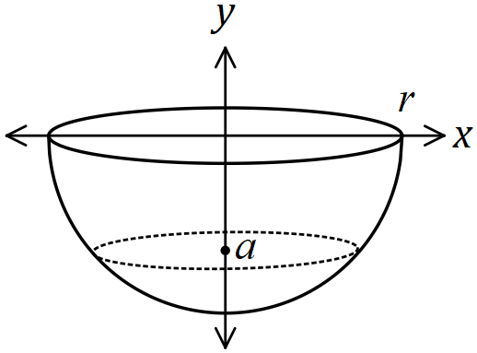

With the circular rim level, a liquid is poured into the hemisphere to a depth of , measured from the bottom of the hemisphere, where $0≤a≤r$.

(a) Write a definite integral in terms of $r$, $a$ and $y$ for the volume of liquid in the bowl.

(2 marks)

(b) Use your answer to (a) to show that the volume of liquid in a bowl when it is filled to a depth $a$ is given by $\frac{1}{3}πa^{2}(3r-a)$. (3 marks)

(c) A hemispherical bowl, with an internal radius of $21$ cm, is filled with water at a constant rate from empty to full in $343$ seconds. Determine the rate of increase of the depth of water at the instant the hemisphere contains cm3 of water. (5 marks)

Question 19 (10 marks)

The inner surface of a hemispherical bowl can be modelled by rotating part of the circle with equation , about the axis.



With the circular rim level, a liquid is poured into the hemisphere to a depth of , measured from the bottom of the hemisphere, where $0≤a≤r$.

(a) Write a definite integral in terms of $r$, $a$ and $y$ for the volume of liquid in the bowl.

(2 marks)

|  |
| --- |
| **Solution** |
| $$V=\int_{-r}^{-r+a}{π\left(r^{2}-y^{2}\right)}dy \left(=\int_{r-a}^{r}{π\left(r^{2}-y^{2}\right)}dy\right)$$ |
| **Specific behaviours** |
| ✓ correct integrand and $dx$ ✓ correct limits |

(b) Use your answer to (a) to show that the volume of liquid in a bowl when it is filled to a depth $a$ is given by $\frac{1}{3}πa^{2}(3r-a)$. (3 marks)

|  |
| --- |
| **Solution** |
| $$V=π{\left[r^{2}y-\frac{y^{3}}{3}\right]}_{-r}^{-r+a} \\ =\frac{π}{3}\left[\left(3r^{2}(a-r)-{\left(a-r\right)}^{3}\right)-\left(3r^{2}(-r)-{\left(-r\right)}^{3}\right)\right] \\ =\frac{π}{3}[3r^{2}a-3r^{3}-\left(a^{3}-3a^{2}r+3ar^{2}-r^{3}\right)-\left(-3r^{3}+r^{3}\right)] \\ =\frac{π}{3}\left[3r^{2}a-3r^{3}-{ha}^{3}+3a^{2}r-3ar^{2}+r^{3}+2r^{3}\right] \\ =\frac{π}{3}[-a^{3}+3a^{2}r] \\ =\frac{1}{3}πa^{2}\left(3r-a\right)$$ |
| **Specific behaviours** |
| ✓ correct antiderivative and substitution of limits seen  ✓ correct expansion of ${\left(a-r\right)}^{3}$ seen (or ${\left(r-a\right)}^{3}$)  ✓ correct simplification seen |

(c) A hemispherical bowl, with an internal radius of $21$ cm, is filled with water at a constant rate from empty to full in $343$ seconds. Determine the rate of increase of the depth of water at the instant the hemisphere contains cm3 of water. (5 marks)

|  |
| --- |
| **Solution** |
| $$\frac{dV}{dt}=\frac{2}{3}π{\left(21\right)}^{3}÷343=18π {\text{cm}}^{3}/\text{s} (≈56.5)$$ $$V=684π=\frac{1}{3}πa^{2}\left(3(21)-a\right)⇒a=6$$ $$\frac{dV}{da}=π\left(2ra-a^{2}\right) \\ =π\left(2\left(21\right)\left(6\right)-6^{2}\right) \\ =216π (≈678.6)$$ $$\frac{da}{dt}=\frac{da}{dV}×\frac{dV}{dt} \\ =\frac{1}{216π}×18π$$ $$\frac{da}{dt}=\frac{1}{12} \text{cm/s }(=0.08\overline{3})$$ |
| **Specific behaviours** |
| ✓ calculates  ✓ calculates height  ✓ calculates $dV/da$ ✓ uses chain rule  ✓ correct rate |

Question 9 (5 marks)

Part of the graph of $y=6\sin{3x}$ is shown below.

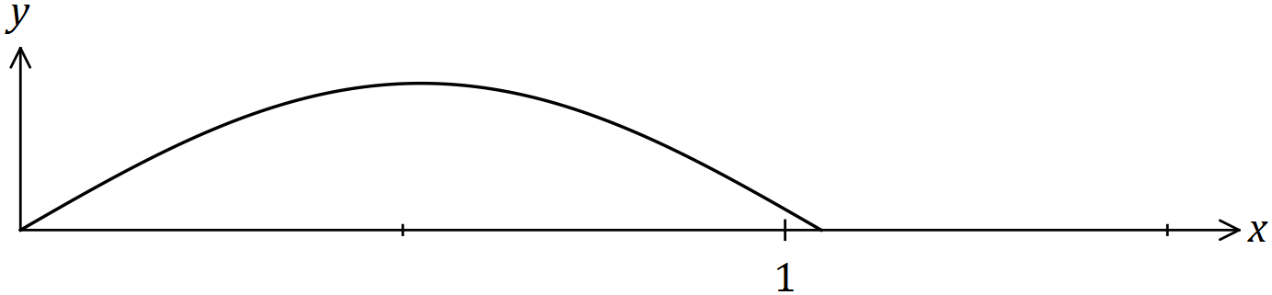

Show that when the part of the curve between $x=0$ and $x=\frac{π}{6}$ is rotated about the $x$ axis, the volume of the solid generated is $3π^{2}$. Clearly indicate all trigonometric identities used.

Question 9 (5 marks)

Part of the graph of $y=6\sin{3x}$ is shown below.



Show that when the part of the curve between $x=0$ and $x=\frac{π}{6}$ is rotated about the $x$ axis, the volume of the solid generated is $3π^{2}$. Clearly indicate all trigonometric identities used.

|  |
| --- |
| **Solution** |
| $$V=π\int_{0}^{\frac{π}{6}}{6^{2}\sin^{2}{3x}}dx$$ $$\sin^{2}{3x}=\frac{1}{2}(1-\cos{6x})$$ $$36\sin^{2}{3x}=18\left(1-\cos{6x}\right) \\ =18-18\cos{6x}$$ $$V=π\int_{0}^{\frac{π}{6}}{18-18\cos{6x}}dx \\ ={π\left[18x-3\sin{6x}\right]}_{0}^{\frac{π}{6}} \\ =π\left(3π-0\right)-π(0-0) \\ =3π^{2}$$ |
| **Specific behaviours** |
| ✓ writes correct integral to evaluate  ✓ shows identity for  ✓ substitutes to obtain expression in terms of  ✓ integrates correctly  ✓ substitutes all limits (and simplifies) |

Question 12 (5 marks)

Part of the graph of $y=e^{\sin{\sqrt{2x}}}$ is shown below.

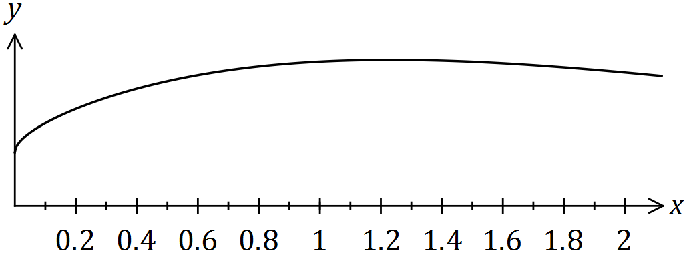

(a) Use numerical integration with three equal width trapeziums to estimate the area between the curve, the $x$-axis, the $y$-axis and the line $x=1.8$. (4 marks)

(b) Briefly explain how to improve the accuracy of your estimate in (a). (1 mark)

Question 12 (5 marks)

Part of the graph of $y=e^{\sin{\sqrt{2x}}}$ is shown below.



(a) Use numerical integration with three equal width trapeziums to estimate the area between the curve, the $x$-axis, the $y$-axis and the line $x=1.8$. (4 marks)

|  |
| --- |
| **Solution** |
| $$f\left(0\right)=1 \\ f\left(0.6\right)=2.3198 \\ f\left(1.2\right)=2.6852 \\ f\left(1.8\right)=2.6832$$ $$T\left(1\right)=\frac{1+2.3198}{2}×0.6=1.0299 \\ T\left(2\right)=1.5452 \\ T\left(3\right)=1.5888$$ $$\text{Area}=4.164 \text{(4 sf)}$$ |
| **Specific behaviours** |
| ✓ calculates $f\left(x\right)$ for  ✓ uses trapezium rule  ✓ area of one trapezium correct to at least 3rd decimal place  ✓ area rounded to 3 or more (ie 4, 5, ...) sf |

(b) Briefly explain how to improve the accuracy of your estimate in (a). (1 mark)

|  |
| --- |
| **Solution** |
| Use a larger number of trapeziums. |
| **Specific behaviours** |
| ✓ indicates more trapeziums |

Question 19 (12 marks)

An inverted right cone of diameter 90 cm and height 15 cm is being filled with water at a constant rate of cm3 per second. Initially the cone contains cm3 of water. Let be the radius of the surface of the water and be the depth of water after seconds.

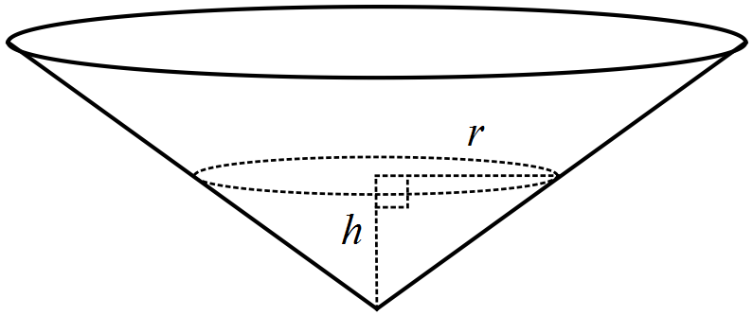

(a) Show that the relationship between the volume of water in the cone, cm3, and the radius is given by $V=\frac{π}{9}r^{3}$. (2 marks)

(b) Show that $\begin{matrix}dr \\ \overline{dt}\end{matrix}=\begin{matrix}15 \\ \overline{r^{2}}\end{matrix}$. (2 marks)

(c) Determine the rate of change of radius $r$ when $t=5$. (2 marks)

(d) Use the differential equation from (b) to determine a relationship between the radius $r$ and time $t$. (4 marks)

(e) Calculate the time required to completely fill the cone. (2 marks)

Question 19 (12 marks)

An inverted right cone of diameter 90 cm and height 15 cm is being filled with water at a constant rate of cm3 per second. Initially the cone contains cm3 of water. Let be the radius of the surface of the water and be the depth of water after seconds.



(a) Show that the relationship between the volume of water in the cone, cm3, and the radius is given by $V=\frac{π}{9}r^{3}$. (2 marks)

|  |
| --- |
| **Solution** |
| $$h=\frac{r}{3}, V=\frac{1}{3}πr^{2}\left(\frac{r}{3}\right)=\frac{π}{9}r^{3}$$ |
| **Specific behaviours** |
| ✓ relates $r$ and  ✓ substitutes and simplifies cone volume |

(b) Show that $\begin{matrix}dr \\ \overline{dt}\end{matrix}=\begin{matrix}15 \\ \overline{r^{2}}\end{matrix}$. (2 marks)

|  |
| --- |
| **Solution** |
| $$\frac{dV}{dr}=\frac{π}{3}r^{2} \text{and}\frac{dV}{dt}=5π$$ $$\frac{dr}{dt}=\frac{dr}{dV}×\frac{dV}{dt}=\frac{3}{πr^{2}}×5π=\frac{15}{r^{2}}$$ |
| **Specific behaviours** |
| ✓ indicates dV/dr and dV/dt  ✓ uses chain rule to obtain expression for dr/dt |

(c) Determine the rate of change of radius $r$ when $t=5$. (2 marks)

|  |
| --- |
| **Solution** |
| $$V=56π+25π=81π$$ $$\frac{π}{9}r^{3}=81π⇒r=9$$ $$\frac{dr}{dt}=\frac{15}{9^{2}}=\frac{5}{27} \text{cm/s}$$ |
| **Specific behaviours** |
| ✓ calculates radius  ✓ substitutes to obtain rate |

(d) Use the differential equation from (b) to determine a relationship between the radius $r$ and time $t$. (4 marks)

|  |
| --- |
| **Solution** |
| $$\frac{dr}{dt}=\frac{15}{r^{2}}$$ $$\int{r^{2}}dr=\int{15}dt$$ $$\frac{r^{3}}{3}=15t+c$$ $$c=\frac{9^{3}}{3}-15\left(5\right)=168$$ $$r^{3}=45t+504$$ |
| **Specific behaviours** |
| ✓ separates variables  ✓ anti-differentiates correctly  ✓ determines constant  ✓ correct relationship |

(e) Calculate the time required to completely fill the cone. (2 marks)

|  |
| --- |
| **Solution** |
| $${45}^{3}=45t+504$$ $$t=2013.8 \text{s}$$ |
| **Specific behaviours** |
| ✓ writes equation  ✓ determines time |